**Arquitectura Modulo Facturación Electrónica Localización Argentina 2019. Incluye FCE**

1. Diagrama de Contexto:

Pantalla Solicitar CAE

Dex MapeaResultadoTicket

Dex CreateXMLTributos(XMLTrib, cTributos, SOPTypeToInt('SOP Type'), 'SOP Number');

Dex CreateXMLIva(XMLIva, SOPTypeToInt('SOP Type'), 'SOP Number');

Dex CreateXMLOpcional(XMLOpcional, SOPTypeToInt('SOP Type'), 'SOP Number', sCodComp);

Dex CreateXMLCbtesAsoc(XMLCbtesAsoc, SOPTypeToInt('SOP Type'), 'SOP Number', sCodComp,cuit);

Dex CreateXMLCbtesAsocFC

1. ACA_WSFE.dll:
   1. Desarrollado en VB bajo Visual Studio 2017
   2. Clases:
      1. Principal:
         1. Function ObtieneTicketMSAL

(

ByVal strProdMode1 As String,

ByVal strUrlWsaaWsdl1 As String,

ByVal strIdServicioNegocio1 As String,

ByVal strRutaCertSigner1 As String,

ByVal strPasswordSecureString1 As String,

ByVal strProxy1 As String,

ByVal strProxyUser1 As String,

ByVal strProxyPassword1 As String,

ByVal Service1 As String,

Optional ByVal DifGMTBA As Integer = 3

) As String

* + - 1. Function UltimoNumeroTESTv1

(

ByVal cuit As String,

ByVal token As String,

ByVal sign As String,

ByVal tipo_cbte As String,

ByVal punto_vta As String,

ByRef codeerr As String,

ByRef msgerr As String

) As String

* + - 1. Function UltimoNumeroProdv1

(

ByVal cuit As String,

ByVal token As String,

ByVal sign As String,

ByVal tipo_cbte As String,

ByVal punto_vta As String,

ByRef codeerr As String,

ByRef msgerr As String

) As String

* + - 1. Function ObtieneCAEPIMSAL

(

ByVal cuit As String, ByVal strToken As String,

ByVal strToken As String, ByVal strSign As String,

ByVal strcantidadreg As String, ByVal presta_serv As String,

ByVal tipo_doc As String, ByVal nro_doc As String,

ByVal tipo_cbte As String, ByVal punto_vta As String,

ByVal cbt_desde As String, ByVal cbt_hasta As String,

ByVal imp_total As String, ByVal imp_tot_conc As String,

ByVal imp_neto As String, ByVal impto_liq As String,

ByVal impto_liq_rni As String, ByVal imp_op_ex As String,

ByVal imp_trib As String, ByVal fecha_cbte As String,

ByVal fecha_serv_desde As String, ByVal fecha_serv_hasta As String,

ByVal fecha_venc_pago As String, ByVal concepto As String,

ByVal moneda As String, ByVal tipo_cbio As String,

ByVal tributos As String, ByVal ivastr As String,

ByVal adicionalesstr As String, ByVal cbtesasocstr As String

) As String

* + - 1. Function ObtieneCAEPIPRODMSAL

(

ByVal cuit As String, ByVal strToken As String,

ByVal strToken As String, ByVal strSign As String,

ByVal strcantidadreg As String, ByVal presta_serv As String,

ByVal tipo_doc As String, ByVal nro_doc As String,

ByVal tipo_cbte As String, ByVal punto_vta As String,

ByVal cbt_desde As String, ByVal cbt_hasta As String,

ByVal imp_total As String, ByVal imp_tot_conc As String,

ByVal imp_neto As String, ByVal impto_liq As String,

ByVal impto_liq_rni As String, ByVal imp_op_ex As String,

ByVal imp_trib As String, ByVal fecha_cbte As String,

ByVal fecha_serv_desde As String, ByVal fecha_serv_hasta As String,

ByVal fecha_venc_pago As String, ByVal concepto As String,

ByVal moneda As String, ByVal tipo_cbio As String,

ByVal tributos As String, ByVal ivastr As String,

ByVal adicionalesstr As String, ByVal cbtesasocstr As String

) As String

1. Ventanas:
   1. Entrada de Transacciones de Venta. Botón Guardar:

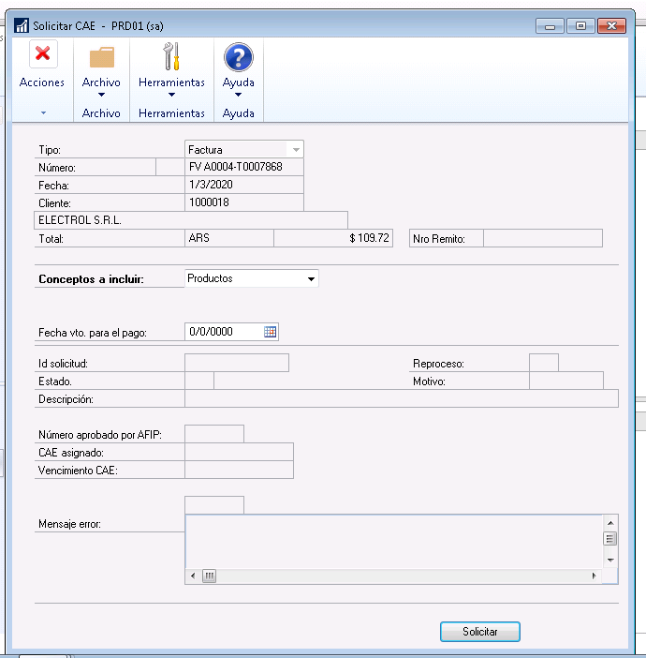

Function MapeaResultadoTicket

Function CreateXMLTributos(XMLTrib, cTributos, SOPTypeToInt('SOP Type'), 'SOP Number');

Function CreateXMLIva(XMLIva, SOPTypeToInt('SOP Type'), 'SOP Number');

Function CreateXMLOpcional(XMLOpcional, SOPTypeToInt('SOP Type'), 'SOP Number', sCodComp);

Function CreateXMLCbtesAsoc(XMLCbtesAsoc, SOPTypeToInt('SOP Type'), 'SOP Number', sCodComp,cuit);

Function CreateXMLCbtesAsocFC

Function ObtieneCAE